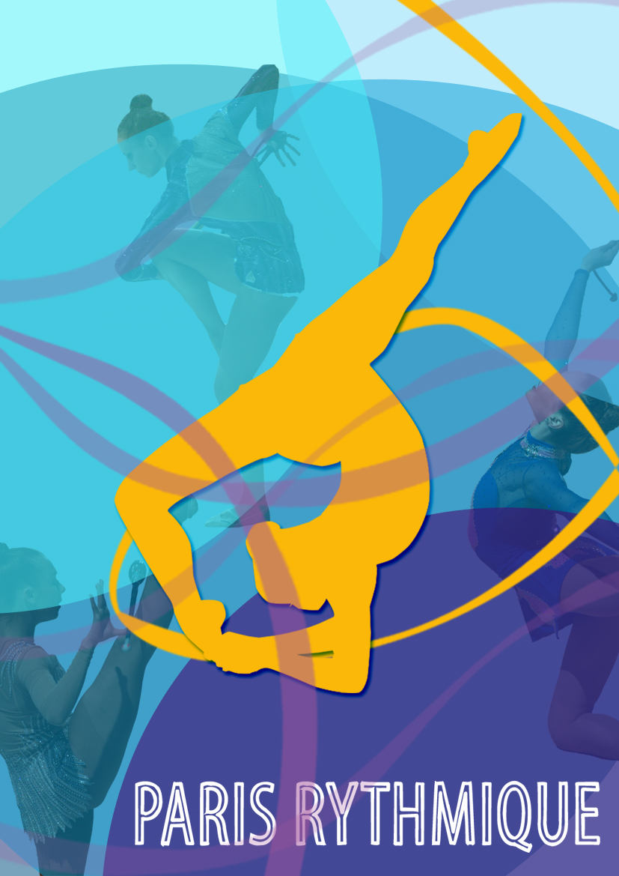
Paris, September, 28th 2012

To the presidents of Rhythmic Gymnastics associations

Madam, Sir,

Once again, we are glad to invite you to the

Paris Rythmique tournament for its 5th edition which will occur
on December 23rd, 2012 in Paris.

The number of clubs which take part to our tournament is growing steadily and we hope that it will be the same thing for this new edition. We are looking forward to discovering the work you have done with your gymnasts.

If you are interested, you will find attached the information necessary to take part to the 5th edition of the Paris Rythmique tournament. To participate, you will have to send MANDATORILY the data asked before November, 30th, 2012.

We would be honored to host you for this event.
Best regards.

Emilie CLEMENCEAU
Presidente of Paris Rythmique

Linsay BEROL
Vice-Presidente of Paris Rythmique

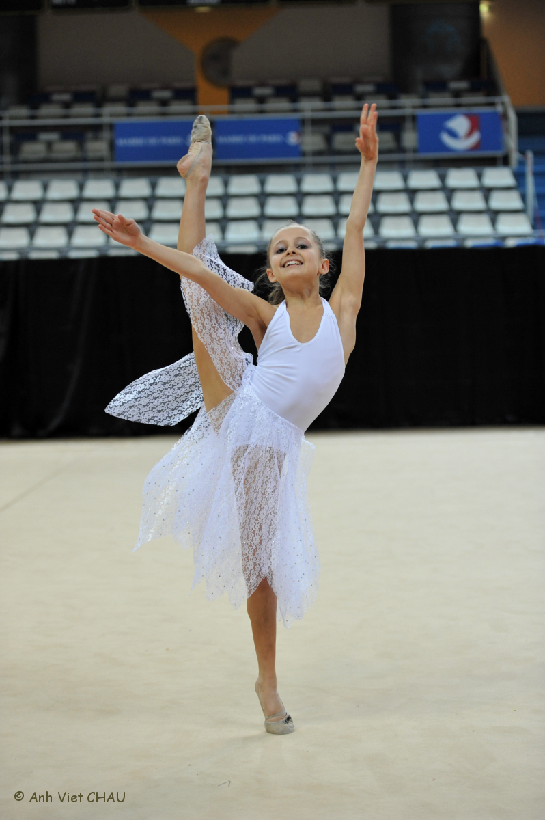

1. Presentation of the Tournament

a. Date & place of competition

► Date of the Tournament

The 5th Tournament Paris Rythmique will occur on 23trd, December 2012 at 11AM (the schedule may change depending of the number of participants: the definitive one will be given to you at the beginning of December in the club file we will send you by email).

► Saturday, December, 22nd

13h-18h Training (schedule will be given in the club file)

► Sunday, December, 23rd

9h-11h Training
11h-13h « Prestige category » with bonus routines
13h-14h Break
14h-18h « Elite category » with bonus routines
18h-19h Exhibitions
19h-20h Friendship drink

► Place of the Tournament
Address of the sports hall
Halle Coubertin
82, avenue Georges Lafont
75016 Paris - FRANCE

How to go to the sports hall by public transports
- By subway:
  - Line 9 (station Porte de Saint Cloud) – the nearest station
  - Line 8 (station Balard) and Line 10 (station Porte d’Auteuil) – around 10 min of walk

  - By tramway:
T2 (station Pont du Garigliano) - around 10 min of walk

- By bus :
Lines PC1, 22, 62, 72, 175, 189, 289, station Porte de Saint Cloud

Useful: the map of Paris metro

You can download this map on RATP website: www.ratp.fr.
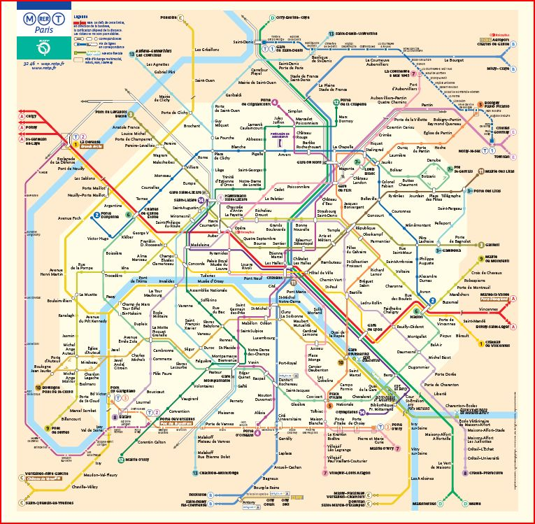
Station Porte de Saint-Cloud, to get to Halle de Coubertin

b. Technical information

► Categories
Each delegation will be able to participate with ONE team, either in Prestige category or in Elite category.
- The Prestige category:
- 1 individual routine for each apparatus (1 with hoop, 1 with ball, 1 with clubs, 1 with ribbon) that is to say 4 individual routines in total
- 1 “bonus routine” to choose between:
  - An individual routine, free apparatus
  - A group (5 gymnasts), free apparatus

The following table sums up the notation system used during the tournament for “Coupe Prestige”.
Duration | Number of difficulties |  | D1 | D2 | Artistic | Execution
Prestige Group  2’15 to 2 ‘30 | 14 maximum | * Difficulties A-F  * At least 6 exchanges by throw | / 5 points | / 5 points | / 10 points | / 10 points
Prestige Individual  1’15 to 1’30 | 12 maximum | * Difficulties A-F  * 8 difficulties of the compulsory corporal group minimum, in a routine of 10 to12 difficulties  * 6 difficulties of the compulsory corporal group minimum, in a routine of 9 difficulties or less | / 5 points | / 5 points | / 10 points | / 10 points

- The Elite category:
- Two individual routines for each apparatus (2 with hoop 2 with ball, 2 with clubs, 2 with ribbon), that is to say 8 individual routines in total
- An « extra routine » to choose between :
  - An individual routine, free apparatus
      - A duet (2 gymnasts), free apparatus
      - A group (5 gymnasts), free apparatus

The following table sums up the notation system used during the tournament for “Coupe Elite”.
Duration | Number of difficulties |  | D1 | D2 | Artistic | Execution
Elite Group  2’15 to 2 ‘30 | 14 maximum | * Difficulties A to J&+  * At least 6 exchanges by throw | / 10 points | /10 points | / 10 points | / 10 points
Elite Individual  1’15 to 1’30 | 12 maximum | * Difficulties A to J&+  * 8 difficulties of the compulsory corporal group minimum, in a routine of 10 to12 difficulties  * 6 difficulties of the compulsory corporal group minimum, in a routine of 9 difficulties or less | / 10 points | /10 points | / 10 points | / 10 points
Elite Duet  1’30 à 1’45 | 12 maximum | * Difficulties A to J&+  * At least 4 exchanges by throw | / 10 points | /10 points | / 10 points | / 10 points
Please note that for both categories the apparatuses used will have to be in accordance with FIG norms.

► Age of the participants
There is no age restriction. However, here are the apparatuses that the gymnasts can present depending of their age:
- Future gymnasts (2003 and after): hoop;
- Hope gymnasts (2000-2002): hoop and/or ball;
- Juniors gymnasts (1997-1998-1999): hoop, ball, clubs, ribbon;
- Seniors gymnasts (1996 and before): hoop, ball, clubs, ribbon.
IMPORTANT: please note that we will not accept to modify the categories for a gymnast. Consequently, a girl born in 2003 will only compete with hoop. Hope gymnasts will only present hoop and or ball. No derogation will be accepted.

► Notation system
The competition will be held under FIG Code of Points. Each gymnast will be ranked as follows:
- Difficulty: this mark is the average of D1 and D2
Calculus of the mark:
► Mark= (D1+D2)/2 + A + E (out of 25 points in Prestige categories, out of 30 points in Elite ones)

- Artistic: 10 points maximum
- Execution: 10 points maximum

► Exhibition
Each association is invited to present one exhibition at the end of the competition. An award will be offered by the organization for the most beautiful one. If you want to show an exhibition, precise it when sending the nominative entry.

► Important

Each exhibition should least maximum 2’30 minutes.

► Awards

The best teams and gymnasts will be awarded by several prices.
○ « Prestige Category»

* Best association – Prestige Trophy Paris Rythmique
The Prestige Trophy Paris Rythmique will reward the team presented in Prestige category, which will totalize the higher score after all its routines (this score cannot exceed 125 points):
- 1 individual with ball, mark out of 25 ==> 25 points
- 1 individual with hoop, mark out of 25 ==> 25 points
- 1 individual with clubs, mark out of 25 ==> 25 points
- 1 individual with ribbon, mark out of 25 ==> 25 points
- 1 « bonus » routine, mark out of 25 ==> 25 points

* Medals per apparatus and ages
The best routines will be awarded as shown below:
- Best Prestige individual routine by age category:
  - Individual Futures: ranking at hoop
  - Individuals Hopes: ranking at hoop and ball
  - Individuals Juniors: ranking at hoop, ball, clubs and ribbon
  - Individuals Seniors: ranking at hoop, ball, clubs and ribbon
- Best Prestige formations :
  - The best group

○ « Elite Category»

* Best association – Elite Trophy Paris Rythmique
The Elite Trophy Paris Rythmique will reward the team presented in Elite category, which will totalize the higher score after all its routines. This score cannot exceed 270 points (cf. following details):
- 2 individuals with ball, mark out of 30 ==> 60 points
- 2 individuals with hoop, mark out of 30 ==> 60 points
- 2 individuals with clubs, mark out of 30 ==> 60 points
- 2 individuals with ribbon, mark out of 30 ==> 60 points
- 1 « bonus » routine, mark out of 30 ==> 30 points

* Medals per apparatus and ages
The best routines will be awarded as shown below:
- Best Elite individual routine by age category:
  - Individual Futures: ranking at hoop
  - Individuals Hopes: ranking at hoop and ball
  - Individuals Juniors: ranking at hoop, ball, clubs and ribbon
  - Individuals Seniors: ranking at hoop, ball, clubs and ribbon

- Best Elite formations :
  - The best group
  - The best duet

○ Miss Paris Rythmique
This reward will be given by the audience. It will reward the audience’s favorite gymnast.

○ Miss exhibition
This special price will be given by the organizers for the best exhibition.

► Fees
Participation fees:
- 20 € for individuals
- 30 € for a duet
- 40 € for a group

The whole fees will have to be paid:
- Before the competition by transfer, check or cash money.
- At the arrival of the delegation by check or cash money.
- The delegation won’t be able to take part to the competition if payment isn’t received.
c. Insurance

All the clubs will need insurance. Our insurance will not cover the gymnasts’ accidents. In case of necessity, insurance may be offered to you. Contact us for more information.

d. Contacts & permanences

Do not hesitate to contact us for further information:

► Mail
parisrythmiquetournoi@gmail.com

► Phone
+336 62 41 58 26

► Website
http://parisrythmique.free.fr

A phone permanence will be settled on Saturday, December, 22nd from 10 AM. To contact it, please call +33 6 62 41 58 26.

A permanence will also be held in the sports hall on Saturday, December, 22nd from 12.30 until18.30. During that permanence, you will be able to take your association’s folder and to let your gymnasts train.

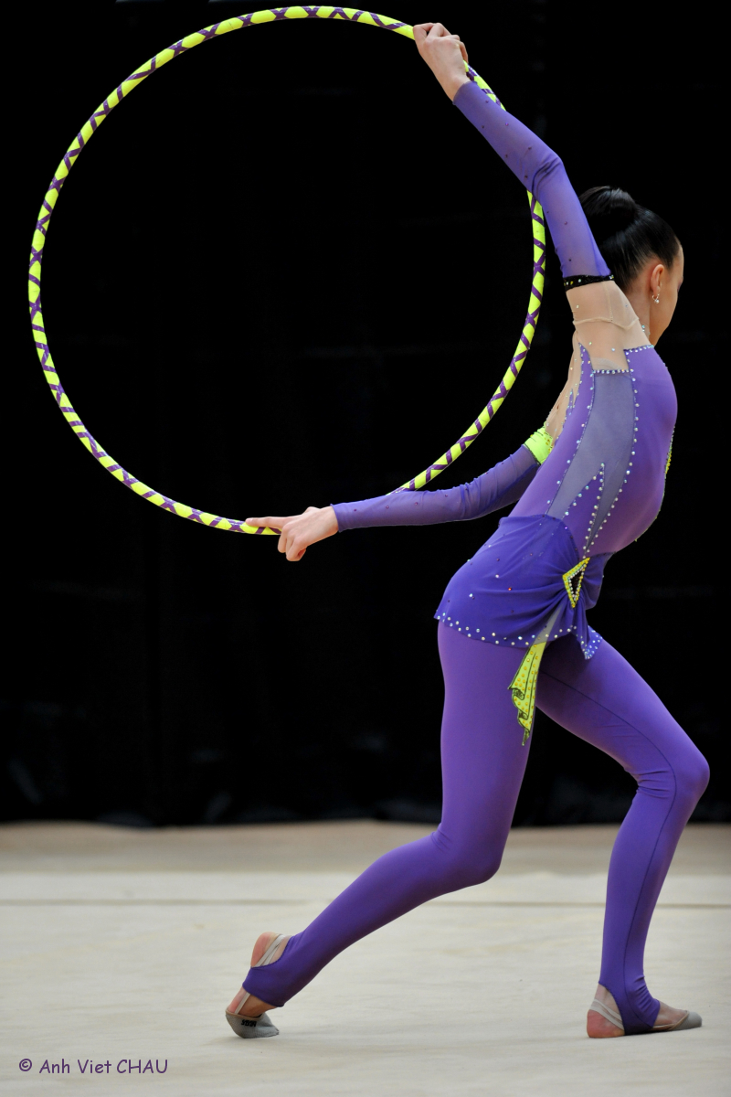
2. Useful information

Order of dvds of the competition

At the end of the competition, a DVD will be available and will offer you the possibility to relive the best moments of the competition. Order it now!

Presentation of the DVD

The DVD will contain all the routines of each team, as well as the exhibitions presented at the end of the competition. It costs 20€.

restOration

There are many restaurants (and for all tastes) in Paris. During the competition, you will have the possibility to go to the snack located in the sports hall, in order to buy sweets, sandwiches, cakes and drinks
We are also organizing a system of lunchboxes for the delegations. It is a useful solution but also a balanced meal. It will be constituted by the following elements (if there are no changes):

1 sandwich
Crisps
Apple
water

In order to be organized properly, we need to know the number of lunchboxes to constitute; you can order some right now for 6 euros each. If you are interested, please let us know.

ORDER OF THE OFFICIAL T SHIRT

The official t-shirt of the tournament is a superb souvenir of this weekend to offer to your gymnasts. You can order them for 13€.

Presentation of the T-shirt

The t-shirt, a short sleeve one (cf picture on the left) will be made with the logo of the Tournament.

<< Example of t-shirt

3. PARTICIPATION DOCUMENTS

a. Participation file

If you are eager to take part to the Paris Rythmique Tournament 2012, please fill the online form available on the following link:
https://docs.google.com/spreadsheet/viewform?fromEmail=true&formkey=dGtHRmRRMV9SVXN4VnEzcEE1ZURRSUE6MQ

The deadline for sending back the whole information (name of the association, gymnasts + birthdate, extras…) is November 30th, 2012.
► Important
- In order to validate your participation, the online form should be filled before November 30th, 2012; otherwise, we would have to cancel your inscription.
- Only the 10 first answers in Prestige category and the 10 first in Elite category will be treated. If you are interested, let us know it as soon as possible.
- Your participation will be validated as soon as you receive a confirmation mail. Please do not buy transport tickets or reserve hotel before you get it.

b. Judgment

Each association will have to provide at least 1 judge for the whole competition. If an association cannot provide a judge, the gymnasts will not be able to participate. Please note that a judges meeting will be held on Sunday, 23rd, December at 10am (depending of the number of participants).

c. Music

The musics should be provided by mp3 ONLY before December 10th. In order to do so, please use the following website:
http://www.wetransfer.com (Email used to send it to us: parisrythmiquetournoi@gmail.com)

In order to send us your musics, please follow the instruction below)
- Name of your association
- Category (Prestige or Elite)
- Apparatus
- Name & surname

Example: the association Paris Rythmique presents a gymnast called Anne Dupont, which does hoop in Prestige category. The mp3 file should be named:

Paris Rythmique – Prestige – Hoop – Anne Dupont

For training sessions, please take your Cds.

d. D1 & D2 files

Each club will have to provide the D1 and D2 files in accordance with the FIG norms before the competition. Please do not forget:
- To give 4 copies of the files directly to the organizers in the sports hall before Saturday, December 22nd at 6PM. If you cannot be there on Saturday, you can mail us your files before December 10th. If none of those conditions are respected, the gymnast will compete without files.

- The first name, surname, name of the club, and category (future, hope, junior, senior) should be clearly mentioned on the file.

- Do not forget to tick the apparatus and the kind of difficulty (D1 or D2) on the file.

- Each file should be given in a folder by apparatus. For example, a gymnast competing in clubs and ribbon will have to bring 1f older with the 4 files (2 D1 and 2 D2) for clubs and 1 folder for ribbon. Please do not resort to staples or paperclips.

